Pseudocode is a high-level description of a computer algorithm that uses natural language or informal notation to outline the logic of the algorithm without being tied to any specific programming language syntax. It's a helpful way to plan and design algorithms before implementing them in a particular programming language.

Here's an example of how you might write pseudocode for a simple algorithm to find the maximum value in an array of integers:

Pseudocode:

1. Start

2. Initialize a variable max to store the maximum value, and set it to the first element of the array.

3. Iterate through the array starting from the second element:

a. If the current element is greater than max, update max to the current element.

4. After iterating through all elements, max will contain the maximum value in the array.

5. Print or return the value of max.

6. End

Now, let's translate this pseudocode into Java code:

public class FindMaxValue {

public static void main(String[] args) {

// Given array

int[] array = {5, 10, 3, 8, 15};

// Initialize max with the first element of the array

int max = array[0];

// Iterate through the array to find the maximum value

for (int i = 1; i < array.length; i++) {

if (array[i] > max) {

max = array[i];

}

}

// Print the maximum value

System.out.println("Maximum value in the array: " + max);

}

}

Pseudocode provides a clear and concise way to express algorithms, making it easier to understand and implement them in any programming language, including Java.

Sorting algorithms: Bubble, Selection, Insertion Sort with explnation and with examples:

**Bubble Sort**:

* Bubble sort is a simple sorting algorithm that repeatedly steps through the list, compares adjacent elements, and swaps them if they are in the wrong order. The pass through the list is repeated until the list is sorted.
* This algorithm suites for small data sets.
  + I/P: Suppose we have an array **[5, 1, 4, 2, 8]**.

O/p:[1,2,4,5,8]

First index as i and second indexas j

We are going to compare both these elements if 1 is less than 5 if yes we are going to swap two elements and second element will compare with third element in this case second element 5 if 5 is gretharthan 4 again swap

Note: After iteration of the outer loop highest number will be present in the last index.

**package** com.sample;

**public** **class** BubbleSort {

**public** **static** **void** main(String[] args) {

// Declare and initialize an array of integers

**int** arr[] = { 5, 1, 4, 2, 8 };

// Get the length of the array

**int** length = arr.length;

// Print the unsorted array

System.***out***.println("unsorted array");

**for** (**int** i = 0; i < length; i++)

System.***out***.println(arr[i] + " ");

// Bubble Sort Algorithm

**for** (**int** i = 0; i < length; i++) {

// Iterate over the array from the beginning to the end

// At each iteration, the largest element will "bubble up" to its correct position

**for** (**int** j = 1; j < length - i; j++) {

// Compare adjacent elements and swap them if they are in the wrong order

**if** (arr[j - 1] > arr[j]) {

**int** temp = arr[j];

arr[j] = arr[j - 1];

arr[j - 1] = temp;

}

}

}

// Print the sorted array

System.***out***.println();

System.***out***.println("sorted array");

**for** (**int** i = 0; i < length; i++)

System.***out***.println(arr[i] + " ");

}

}

**Bubble Sort**:

* **Explanation**:

Explanation:

**Declaration and Initialization of Array**:

int arr[] = { 5, 1, 4, 2, 8 };

Here, an integer array named **arr** is declared and initialized with some integer values.

**Length of the Array**:

int length = arr.length;

The **length** variable stores the length of the array **arr**.

**Printing Unsorted Array**:

System.out.println("unsorted array");

for (int i = 0; i < length; i++)

System.out.println(arr[i] + " ");

This loop iterates through each element of the array and prints them. It's just a visual representation of the array before sorting.

**Bubble Sort Algorithm**:

for (int i = 0; i < length; i++) {

for (int j = 1; j < length - i; j++) {

if (arr[j - 1] > arr[j]) {

int temp = arr[j];

arr[j] = arr[j - 1];

arr[j - 1] = temp;

}

}

}

This is the implementation of the Bubble Sort algorithm. It consists of two nested loops. The outer loop iterates over each element of the array. The inner loop compares adjacent elements and swaps them if they are in the wrong order. After each iteration of the outer loop, the largest element bubbles up to its correct position.

**Printing Sorted Array**:

System.out.println();

System.out.println("sorted array");

for (int i = 0; i < length; i++)

System.out.println(arr[i] + " ");

Finally, the sorted array is printed. This loop iterates through each element of the sorted array and prints them.

**Selection Sort**:

* Selection sort is a simple sorting algorithm that divides the input list into two parts: the sublist of items already sorted and the sublist of items remaining to be sorted. It repeatedly selects the smallest (or largest, depending on the sorting order) element from the unsorted sublist and swaps it with the leftmost unsorted element.

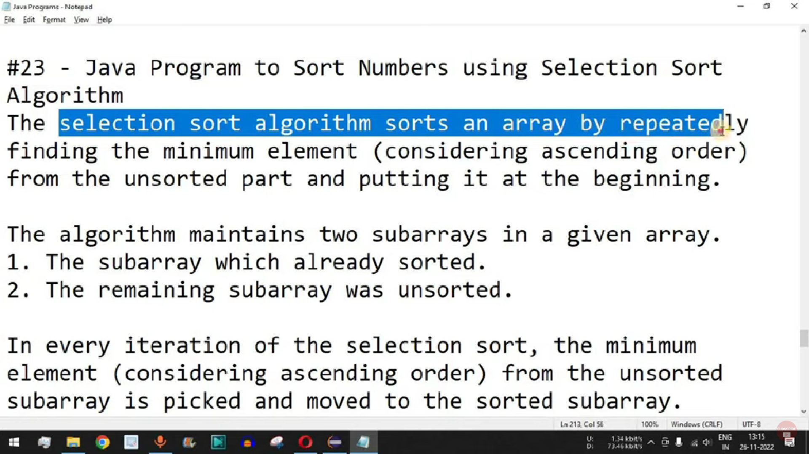

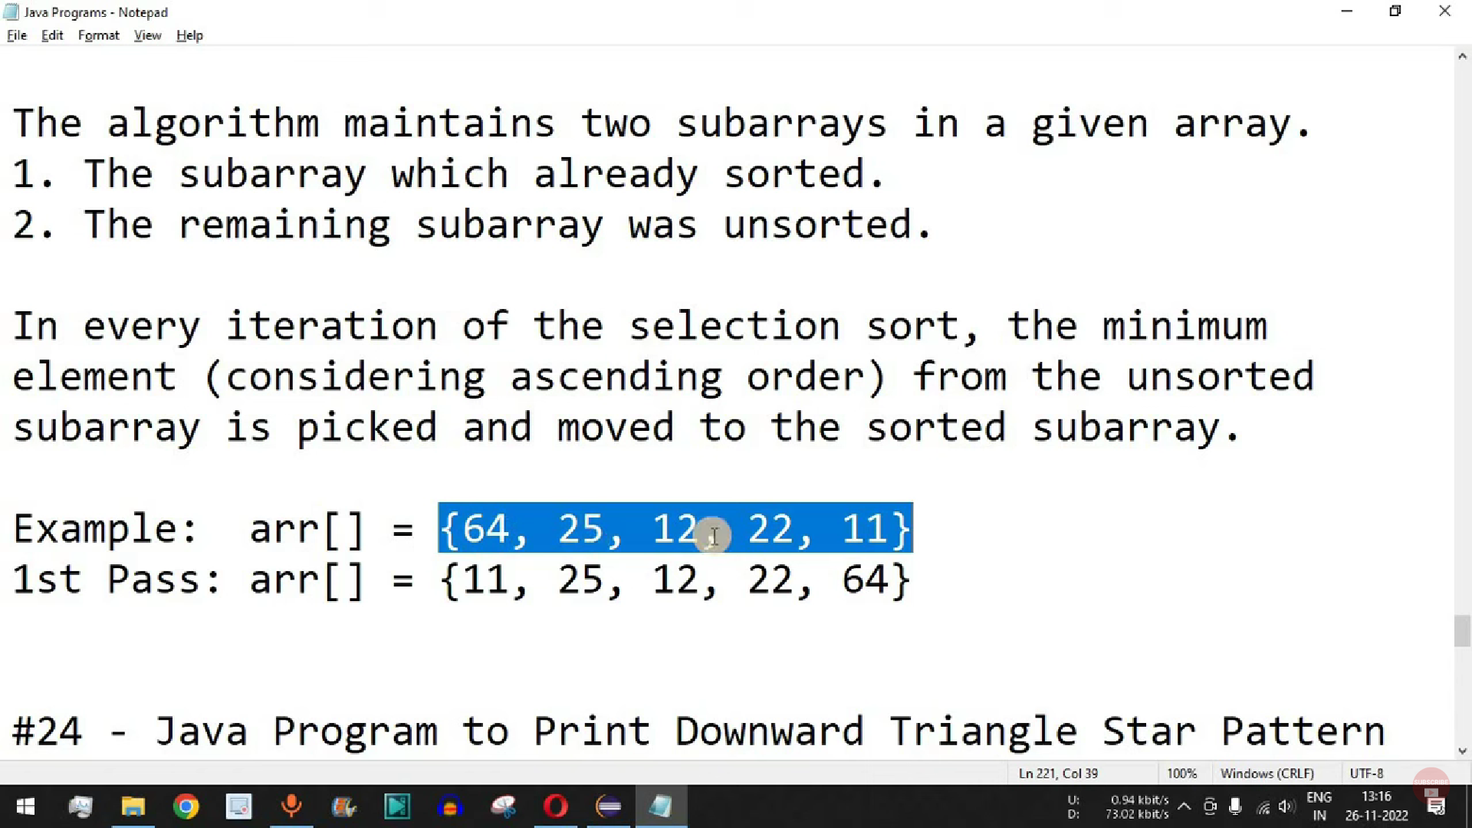

package com.sample;

public class SelectionSort {

public static void main(String[] args) {

// Define an integer array

int arr[] = { 64, 25, 12, 22, 11 };

// Get the length of the array

int length = arr.length;

// Print the unsorted array

System.out.println("unsorted arr :");

for (int i = 0; i < length; i++)

System.out.print(arr[i] + " ");

// Selection Sort Algorithm

for (int i = 0; i < length - 1; i++) {

// Assume the current index has the minimum value

int min_index = i;

// Iterate through the remaining elements to find the minimum value

for (int j = i + 1; j < length; j++) {

// If a smaller value is found, update the min_index

if (arr[min_index] > arr[j])

min_index = j;

}

// Swap the minimum value found with the current index

int temp = arr[min_index];

arr[min_index] = arr[i];

arr[i] = temp;

}

// Print the sorted array

System.out.println();

System.out.println("sorted arr :");

for (int i = 0; i < length; i++)

System.out.print(arr[i] + " ");

}

}

Explanation:

**Declaration and Initialization of Array**:

int arr[] = { 64, 25, 12, 22, 11 };

An integer array named **arr** is declared and initialized with some integer values.

**Length of the Array**:

int length = arr.length;

The **length** variable stores the length of the array **arr**.

**Printing Unsorted Array**:

System.out.println("unsorted arr :");

for (int i = 0; i < length; i++)

System.out.print(arr[i] + " ");

This loop iterates through each element of the array and prints them. It displays the unsorted array.

**Selection Sort Algorithm**:

for (int i = 0; i < length - 1; i++) {

int min_index = i;

for (int j = i + 1; j < length; j++) {

if (arr[min_index] > arr[j])

min_index = j;

}

int temp = arr[min_index];

arr[min_index] = arr[i];

arr[i] = temp;

}

This part implements the Selection Sort algorithm. It consists of two nested loops. The outer loop selects each element of the array one by one. The inner loop finds the minimum element from the remaining unsorted part of the array. After finding the minimum element, it swaps it with the current element.

**Printing Sorted Array**:

System.out.println();

System.out.println("sorted arr :");

for (int i = 0; i < length; i++)

System.out.print(arr[i] + " ");

**Insertion Sort**:

* Insertion sort is a simple sorting algorithm that builds the final sorted list one item at a time. It takes each element from the input list and inserts it into its correct position in the sorted sublist.

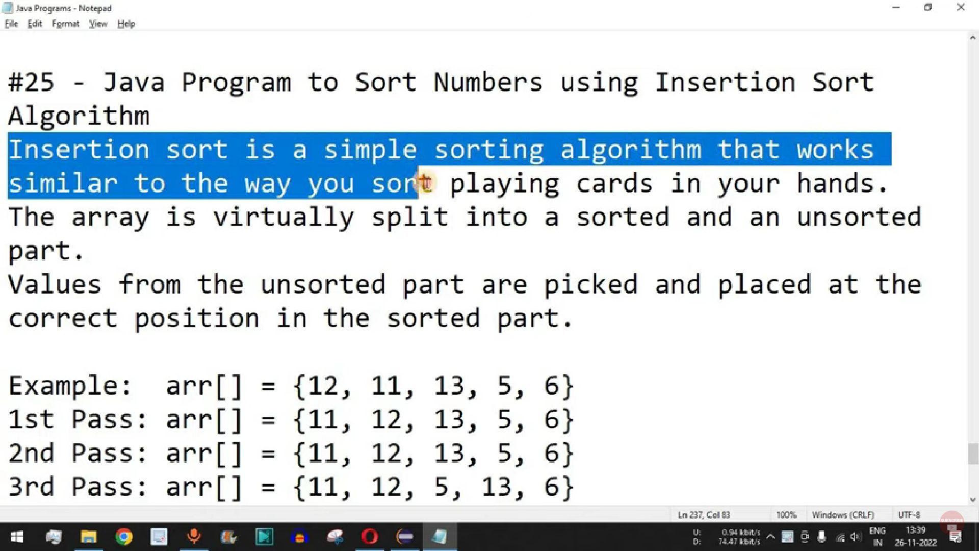

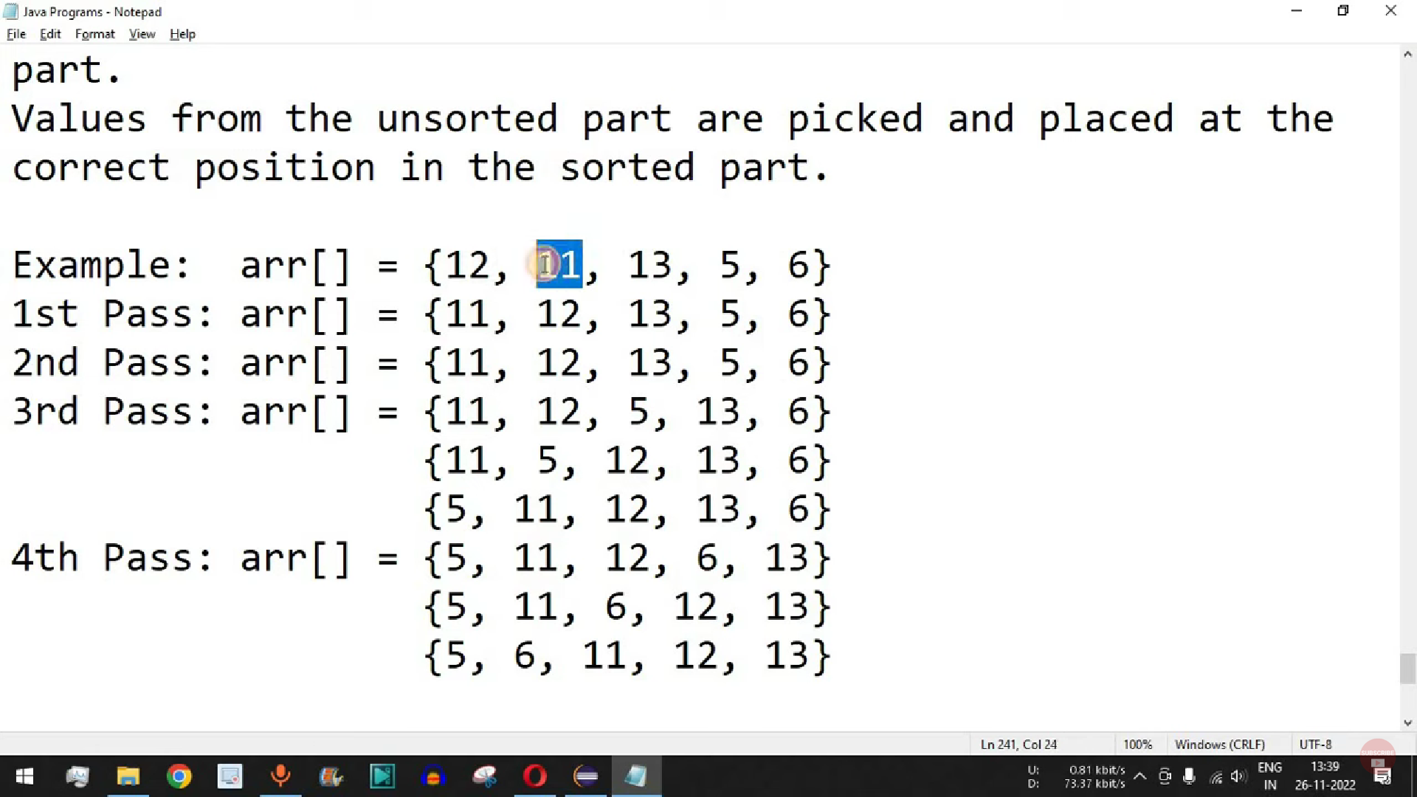

package com.sample;

public class InsertionSort {

public static void main(String[] args) {

// Define an integer array

int arr[] = { 12, 11, 13, 5, 6 };

// Get the length of the array

int length = arr.length;

// Print the unsorted array

System.out.println("unsorted arr :");

for (int i = 0; i < length; i++)

System.out.print(arr[i] + " ");

// Insertion Sort Algorithm

for (int i = 1; i < length; i++) {

int key = arr[i]; // Key is the current element being considered for insertion

int j = i - 1; // Initialize j to the index of the previous element

// Move elements of arr[0..i-1], that are greater than key,

// to one position ahead of their current position

while (j >= 0 && arr[j] > key) {

arr[j + 1] = arr[j]; // Shift elements to the right

j = j - 1; // Move to the previous element

}

arr[j + 1] = key; // Place the key at its correct position

}

// Print the sorted array

System.out.println();

System.out.println("sorted arr :");

for (int i = 0; i < length; i++)

System.out.print(arr[i] + " ");

}

}

Explanation:

1. **Declaration and Initialization of Array**:

int arr[] = { 12, 11, 13, 5, 6 };

1. An integer array named **arr** is declared and initialized with some integer values.
2. **Length of the Array**:

int length = arr.length;

1. The **length** variable stores the length of the array **arr**.
2. **Printing Unsorted Array**:

System.out.println("unsorted arr :");

for (int i = 0; i < length; i++)

System.out.print(arr[i] + " ");

1. This loop iterates through each element of the array and prints them. It displays the unsorted array.
2. **Insertion Sort Algorithm**:

for (int i = 1; i < length; i++) {

int key = arr[i]; // Key is the current element being considered for insertion

int j = i - 1; // Initialize j to the index of the previous element

// Move elements of arr[0..i-1], that are greater than key,

// to one position ahead of their current position

while (j >= 0 && arr[j] > key) {

arr[j + 1] = arr[j]; // Shift elements to the right

j = j - 1; // Move to the previous element

}

arr[j + 1] = key; // Place the key at its correct position

}

This part implements the Insertion Sort algorithm. It iterates through the array, starting from the second element. For each element, it finds the correct position in the sorted part of the array and inserts the element there by shifting the larger elements one position to the right.

**Printing Sorted Array**:

System.out.println();

System.out.println("sorted arr :");

for (int i = 0; i < length; i++)

System.out.print(arr[i] + " ");

Finally, the sorted array is printed.

Searching algorithms: Linear Search, Binary Search with examples:

<https://www.youtube.com/watch?v=ShT3lNRnS_c>

package com.sample;

public class LinearSearch {

public static void main(String[] args) {

// Define an array of integers

int[] arr = { 2, 5, 8, 12, 16, 23, 38, 56, 72, 91 };

// Value to search for

int target = 23;

// Perform linear search

int index = linearSearch(arr, target);

// Display the result

if (index != -1) {

System.out.println("Element found at index: " + index);

} else {

System.out.println("Element not found in the array.");

}

}

// Linear Search function

public static int linearSearch(int[] arr, int target) {

// Iterate through the array

for (int i = 0; i < arr.length; i++) {

// Check if the current element is equal to the target

if (arr[i] == target) {

// Return the index if found

return i;

}

}

// If target not found, return -1

return -1;

}

}

Explanation:

1. **Declaration of Array**:

int[] arr = { 2, 5, 8, 12, 16, 23, 38, 56, 72, 91 };

1. Here, an array named **arr** is defined and initialized with some integer values. This is the array in which we'll be searching for a specific value.
2. **Target Value**:

int target = 23;

1. We define the value we want to search for in the array. In this case, we're looking for the value **23**.
2. **Linear Search Function**:

public static int linearSearch(int[] arr, int target) {

for (int i = 0; i < arr.length; i++) {

if (arr[i] == target) {

return i;

}

}

return -1;

}

This function performs the linear search operation. It takes two parameters: the array to search (**arr**) and the target value to find (**target**). It iterates through the array elements one by one, comparing each element with the target value. If the target value is found, it returns the index of that element. If the target value is not found in the array, it returns **-1**.

**Main Function**:

public static void main(String[] args) {

int index = linearSearch(arr, target);

if (index != -1) {

System.out.println("Element found at index: " + index);

} else {

System.out.println("Element not found in the array.");

}

}

1. In the **main** function, we call the **linearSearch** function with the array **arr** and the target value **target**. We store the result in the **index** variable. If the index is not **-1**, it means the element is found, and we print the index. Otherwise, we print a message indicating that the element was not found in the array.

Linear search is a simple searching algorithm that sequentially checks each element of the array until the target value is found or the end of the array is reached. It's a basic yet fundamental algorithm for searching in arrays.

Binary Search Alogitham:

Binary Search is a searching algorithm that finds the position of a target value within a sorted array. It works by repeatedly dividing in half the portion of the list that could contain the target value, and then comparing the target value to the middle element of the subarray. This process continues until the target value is found or the subarray is empty.

Here's a Java implementation of Binary Search with explanations:

package com.sample;

public class BinarySearch {

public static void main(String[] args) {

// Define a sorted array

int[] arr = { 2, 5, 8, 12, 16, 23, 38, 56, 72, 91 };

// Target value to search for

int target = 23;

// Perform binary search

int index = binarySearch(arr, target);

// Display the result

if (index != -1) {

System.out.println("Element found at index: " + index);

} else {

System.out.println("Element not found in the array.");

}

}

// Binary Search function

public static int binarySearch(int[] arr, int target) {

int left = 0; // Index of the leftmost element

int right = arr.length - 1; // Index of the rightmost element

// Keep searching while the left index is less than or equal to the right index

while (left <= right) {

int mid = left + (right - left) / 2; // Calculate the middle index

// Check if the target is present at the middle

if (arr[mid] == target) {

return mid; // Return the index if found

}

// If the target is greater, ignore the left half

if (arr[mid] < target) {

left = mid + 1;

}

// If the target is smaller, ignore the right half

else {

right = mid - 1;

}

}

// If the target is not found, return -1

return -1;

}

}

Explanation:

1. **Declaration of Array**:

int[] arr = { 2, 5, 8, 12, 16, 23, 38, 56, 72, 91 };

An array named **arr** is defined and initialized with some integer values. It's important to note that the array must be sorted for binary search to work correctly.

**Target Value**:

int target = 23;

1. We define the value we want to search for in the array. In this case, we're looking for the value **23**.
2. **Binary Search Function**:

public static int binarySearch(int[] arr, int target) {

int left = 0; // Index of the leftmost element

int right = arr.length - 1; // Index of the rightmost element

// Keep searching while the left index is less than or equal to the right index

while (left <= right) {

int mid = left + (right - left) / 2; // Calculate the middle index

// Check if the target is present at the middle

if (arr[mid] == target) {

return mid; // Return the index if found

}

// If the target is greater, ignore the left half

if (arr[mid] < target) {

left = mid + 1;

}

// If the target is smaller, ignore the right half

else {

right = mid - 1;

}

}

// If the target is not found, return -1

return -1;

}

This function performs the binary search operation. It takes two parameters: the sorted array to search (**arr**) and the target value to find (**target**). It initializes two pointers, **left** and **right**, which represent the indices of the leftmost and rightmost elements in the array, respectively. It then repeatedly halves the search space by adjusting these pointers until the target value is found or the search space is exhausted.

**Main Function**:

public static void main(String[] args) {

int index = binarySearch(arr, target);

if (index != -1) {

System.out.println("Element found at index: " + index);

} else {

System.out.println("Element not found in the array.");

}

}

1. In the **main** function, we call the **binarySearch** function with the array **arr** and the target value **target**. We store the result in the **index** variable. If the index is not **-1**, it means the element is found, and we print the index. Otherwise, we print a message indicating that the element was not found in the array.

Binary search is a very efficient algorithm for searching in sorted arrays. It has a time complexity of O(log n), where n is the number of elements in the array. This makes it much faster than linear search, especially for large datasets